**INFO 6205**

**Program Structures & Algorithms**

**Fall 2020**

**Assignment 3**

* **Task**

Implement height-weighted Quick Union with Path Compression

* **Output** (few outputs to prove relationship)

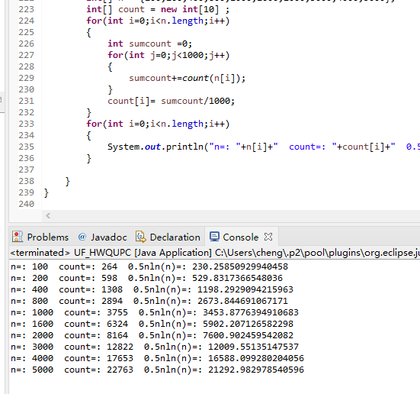

* **Relationship conclusion**

**M(Count)  **

* **Evidence to support relationship** (screen shot and/or graph and/or spreadsheet)

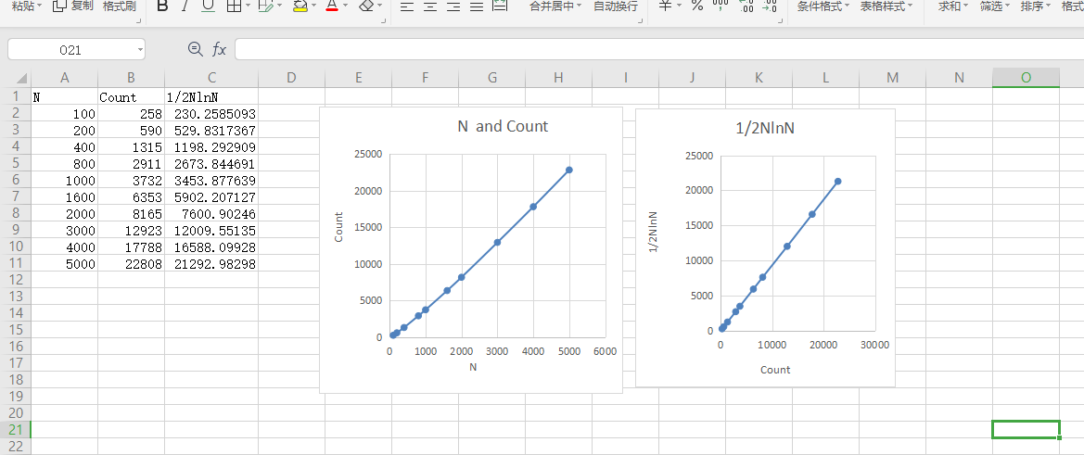

I tested each n value 1000 times, and by looking at the average number of integer pairs required, I found a relationship between N and Count .

As shown in the figure, Count 

* **Screenshot of Unit test passing**

